PalmSHIELD Mercury Series Installation Instructions
PalmSHIELD prides ourselves on having a reputation of being the most user-friendly architectural screen system to install. We have been working directly with installers for over a decade to improve our overall installation.
At the onset of your installation, you can look forward to:
- All of our posts are pre-routed to receive the planks.
- Vinyl and aluminum planks will be pre-notched to slide directly into the posts. Composite planks will come with steel clips to be screwed to the ends of the planks.
- Our hinges are pre-mounted to the gate frames. The remaining half is packaged to be field welded to the steel gate post. You may request that we fully install your hinges if you are sure of site conditions.
- Our drop rods are all pre-mounted to the gate frames.
- Our internal locking devices are all pre-installed on the gate frames.
- You will receive a system layout drawing that provides the distance between posts so you may select the proper planks for each bay.
- You will receive a packing list that indicates the quantity and length of every plank and post.
Important items to review at the start of the installation
- Every PalmSHIELD installation was initiated with a fabrication drawing. This drawing is the basis for your installation. Please follow this drawing to the letter as there is little flexibility in the dimensions.
- Unless stated otherwise on your fabrication drawing, PalmSHIELD systems are to be installed level. As most systems are installed outdoors, most exterior paving is not level. If your surface is not level, you will need to verify and plan accordingly. The Mercury series does provide some flexibility for being installed on slopes. However, the end result may not be attractive as the planks slope from post to post.
- Review the swing of your gate. Will it interfere with any other surface like raised equipment pads and curbing?
Hardware included with your PalmSHIELD Mercury series system
- Metal clips and adjoining screws (composite planks only).
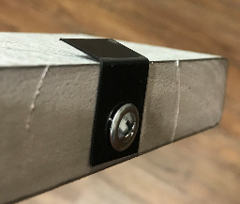
- Ball bearing. These are packaged separately. One ball bearing per hinge.
- Drop rods. These are pre-installed on the gates.
- Locking devices. These are pre-installed on the gates.
- Hinges. Half of the hinge is pre-installed on the gate post. The other half is packaged to be field welded unless instructed otherwise.
- Oil. This oil is to be placed on the tip of each sheet metal screw
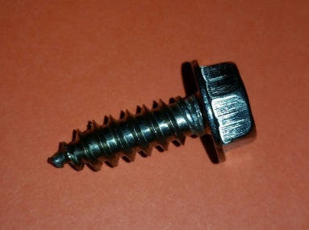
Sheet Metal Screw

Hardware not included.
- Post anchors are not included. Based on 4000 psi concrete, you may consider 5/8” x 6” epoxy anchors or 5/8” x 5 ½” wedge anchors. PalmSHIELD is not responsible for determining anchor type or installations. This should be determined by qualified individual based on site conditions.
- Padlocks for locking devices.

Pre-installation Preparation
- Using some form of marking chalk or tape, layout your system in accordance with your included fabrication drawings. If you do not have these drawings, please inquire with PalmSHIELD for a copy.
- Layout each run from center to center of posts.
- Layout gate openings from inside of post to inside of post.
- Layout the entire system prior to starting to insure it fits your space as you intended.
- If concerned about changing elevations, identify the highest elevation on your site where the system is to be installed. This may be your benchmark for setting your posts. All of your posts will have to be installed to this elevation. A couple hints to make this easy.
  - Start at the highest elevation and level each panel as you go. OR
  - Run a string line along the installation. Set it flush at the point of highest elevation and then level it over the balance of the installation. OR
  - Use a site level and determine the change in elevation at each post.
  - As the elevation drops, you will have to either shim under your posts or install leveling nuts to your anchors.
- If changing elevations are not an issue, start your PalmSHIELD system at a permanent structure such as building or wall. It is to start here and work out into space where you do not have to be concerned about ending gaps.
- PalmSHIELD Mercury series will allow for some slope but the end result may not be agreeable in appearance.

Installation Steps
- Verify your planks and posts compared to your fabrication drawings to assure every plank and post was accurately fabricated. If you identify an error, please contact us as soon as possible and prior to any installation. PalmSHIELD will be responsible for fabrication errors but not installation costs as a result of these errors.
- It is best to install your PalmSHIELD Mercury system by initially setting all your posts per the fabrication drawings.
- If your posts are plated, using the post base plate template provided with your order,
  - use the template to align the first post to your site markings.
  - Make sure the post base plate runs parallel to the run and it is not twisted.
  - Mark the center of the anchor holes.
  - Set your anchors.
- Select your first post based on the drawing. Posts are labeled in accordance with the drawing. You should verify if it is a corner, end, or gate post from the fabrication drawing. This can be identified based on the holes routed to receive the planks in the posts.
- Set your first post. Make sure your post is plumb in all directions. Use this process to set all posts.
- If you are setting your posts in a concrete footing.
  - Dig your holes in accordance with the fabrication drawings.
  - Mix and place your concrete in the hole(s).
  - Stab your posts so it aligns with your site markings or string line.
  - Make sure your post is parallel to the run and is not twisted.
  - Make sure your post is plumb and level.
  - Make sure all posts are set to the same elevation to provide for a level louver installation. This may be done with a level string line or with a site level.
- Once your posts are set, layout your planks in accordance with the fabrication drawings. Your planks will typically be 3” longer than the inside to inside post dimension or 2” shorter than the center to center post dimension.
- If you are installing composite planks, screw the clips to both ends of each plank. The clip should be centered on the plank and the screw should be placed into the end of the plank allowing the flared end of the clip to be adjacent to the side of the plank.
- If you are installing vinyl or aluminum planks, the notch should be present on both ends. In some cases, you may have to raise the notch slightly to catch. You can do this with a flat screw driver.
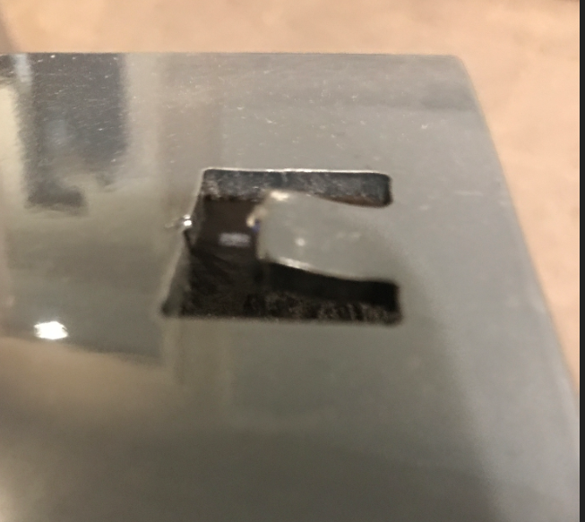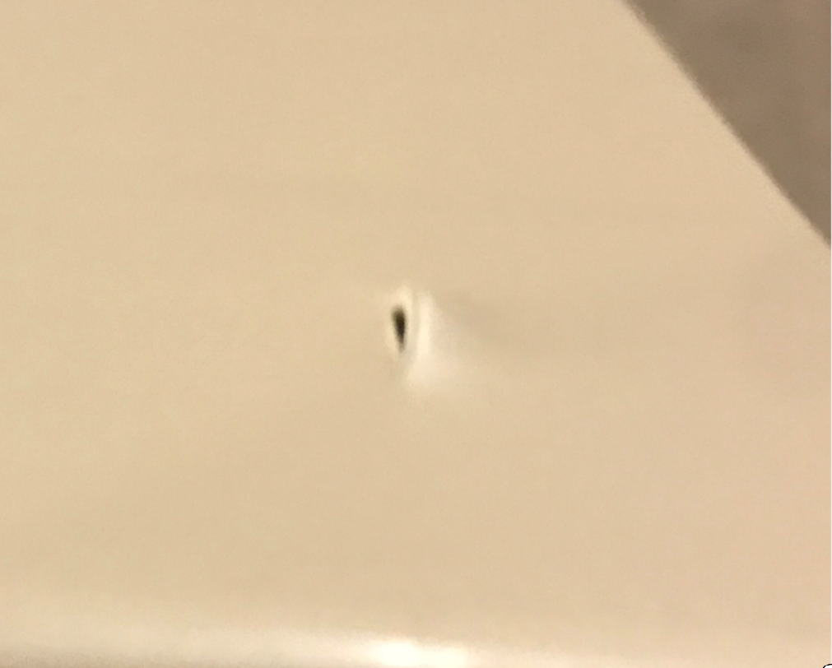
- Before sliding the vinyl or aluminum planks into the post, use a quick ratchet clamp at each end of the plank to slightly compress the plank to ease installation and avoid scratching the post and plank when inserting the plank into the post. Once the plank is inside the post, release the clamp.

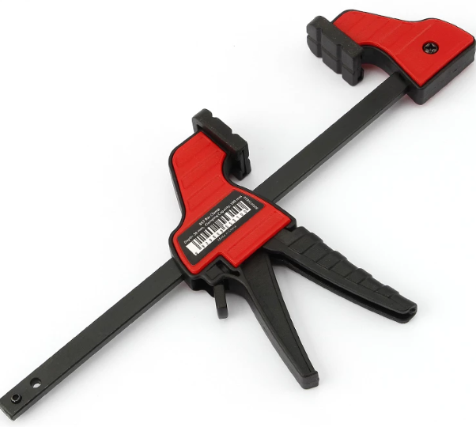
Quick ratchet clamp.

- Slide the planks into the post. Best to start on one end of the project and work your way through the installation.
- The vinyl and aluminum planks will be notched. Make sure the notch is slide-in and through the wall of the post. Applying some effort, pull on the plank to assure it will not easily come-out of the post. If it does, refer to step 9 and repeat.
- Install all the planks in the first bay, then move on to the next bay.

Gate Installation:
- At gate opening, be sure to install gate posts as shown on the drawings. Be sure your openings (inside to inside of post) are accurate.
- Gate installations will vary based on site conditions. You should consider the swing of the gate relative to the grade that it sweeps over and make sure that there is plenty of clearance. Look for steep rising slopes, adjoining equipment pads with a higher elevation and curbing.
- Once you have determined the elevation of your gate, weld the remaining half of the gate hinge to the post. Align the gate hinge so the back of the barrel where it meets the plate is 3/8” in front of the post. In other words, there is a 3/8”gap between the barrel and the gate post.
- Close the gate to the appropriate location. Lower the drop rod and mark the socket location. Repeat for the open position if necessary. For drop rod sockets, we recommend a 1 ½” hammer drill or core bit. You may have to trim the drop rod.
- The internal locking device should not require any further installation. The keys are located in the hardware package.
- PalmSHIELD includes touch-up paint. Closely inspect your installation for any chips or scratches. Hold the can 6” to 8” from the area to be painted and sweep across it until entirely covered. The paint will blend with the powder coated surface.

Tools Needed.
- Socket set
- Set of open end wrenches
- Screw gun or electric drill
- Hammer drill bits for anchors. To be determined by contractor.
- 1 ½” hammer drill or core bit for drop rods (if required).
- Hammer drill bits.
- Level
- Marking tape or paint
- String line.
- Rubber mallet
- Welder (if required for gate installations on steel posts)

